**Sequence Diagram:**

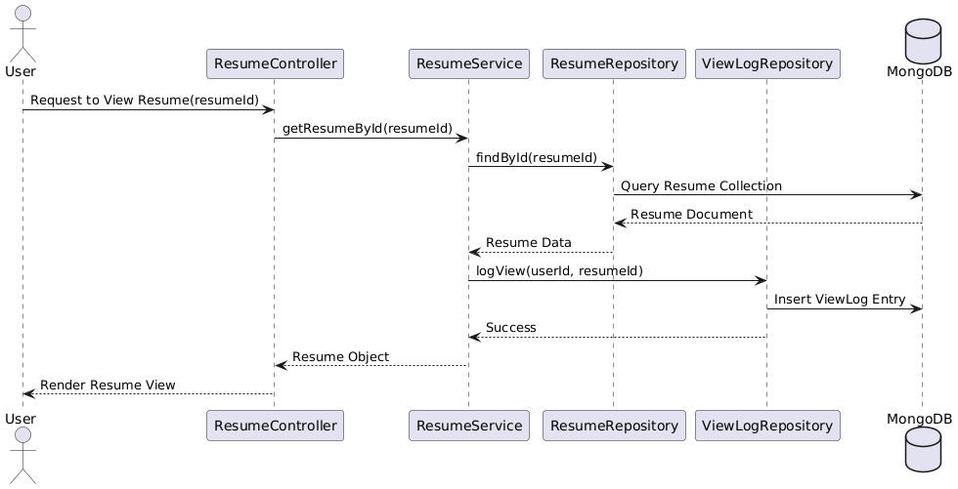

**Class Diagram:**

**State Diagram:**

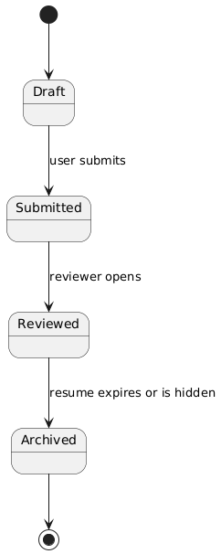

**ERD:**

**Functional Requirements**

|  |  |
| --- | --- |
|  | 1. The system must allow a user to view a specific resume by selecting or clicking on it. |

|  |  |
| --- | --- |
|  | 1. The system must fetch resume data from the database using the resume ID. |

|  |  |
| --- | --- |
|  | 1. The system must render resume content on the user interface. |

|  |  |
| --- | --- |
|  | 1. The system must log each resume view in a ViewLog for tracking. |

|  |  |
| --- | --- |
|  | 1. Only authorized users should be allowed to view resumes. |

**Non-Functional requirements**

1. The system should retrieve and display the resume within 2 seconds.
2. The system should be available 99.9% of the time.
3. All sensitive resume data must be encrypted at rest.
4. The system should scale to handle concurrent views by 10,000 users.
5. Activity logs should be retained for 6 months.